**Pattern Problem – 1**



**n=5**

**for i in range(0,5):**

**for j in range(0,5):**

**print("*",end="")**

**print(" ")**

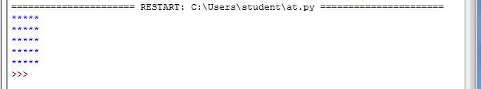

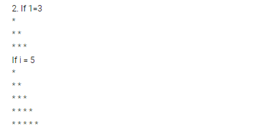

n=int(input("Enter the input"))

for i in range(0,n+1):

for j in range(0,n+1):

if(j<i):

print("*",end="")

print(" ")

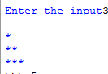

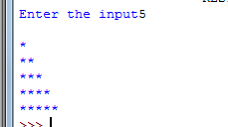

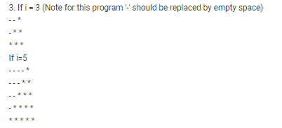

n=int(input())

for i in range(1,n+1):

for j in range(1,n+1):

if(j>n-i):

print("*",end="")

else:

print("-",end="")

print()

